BRITISH AIRWAYS CUSTOMERS REVIEW WITH NEURAL NETWORKS TECHNIQUE.
Abhisshek Paul Kastala (15048897,kastalaa@coventry.ac.uk)
7088CEM Artificial Neural Networks.
Lecturer: Dr Anup Pandey
Word Count: (3423)

- INTRODUCTION:
British Airways is one of the best airlines in the world, so its never-ending task to please customers should be a concern for an organisation operating within such a fiercely competitive business environment. This feedback is key to improve the quality of service and better still, use it to uplift their travel experience. The aim of this study was to harness deep learning methods in examining British Airways customer reviews to provide insights and predict the satisfaction levels of customers.
This research implies that it has a prospect to significantly change the way airlines, specifically British Airways proceed with customer feedback data mining. Using state-of-the-art neural network models allows us to detect patterns and trends in customer sentiments that traditional methods might not catch.
This allows the airline to make well-informed decisions for customer satisfaction, thus better predictions for a more refined and precise prediction of how satisfied customers are with its service.
Ratings and comments are multidimensional difficulty of customer reviews resides at the level that this is BOTH quantitative, while also being qualitative. The task is to take this next-generation evidence and turn it into something that can be analyzed. In this study, we count, with the help of a more elaborate deep learning model that can be used to handle both numerical and textual data allowing us for an overall identification on customer opinions.
  - Literature Review
    - Sentiment Analysis Using Deep Learning:
A study by Liu et al. (2018) demonstrated the effectiveness of LSTM networks in sentiment analysis tasks, highlighting their ability to capture long-term dependencies in textual data.
    - Customer Review Analysis:
Kim et al. (2019) explored the use of GRU networks for analyzing customer reviews, showing that GRUs can achieve competitive performance with fewer parameters compared to LSTMs.
    - Neural Networks for Text Classification:
Zhang et al. (2020) reviewed various neural network architectures for text classification, emphasizing the importance of selecting appropriate models based on the task and dataset characteristics.
  - Thesis Statement
This project aims to evaluate the performance of RNN, LSTM, and GRU networks in analyzing British Airways customer reviews, identify key factors influencing customer satisfaction, and provide actionable insights for improving service quality.
- RELATED WORK:
The problem of analyzing customer reviews for British Airways can be contextualized within the broader field of sentiment analysis and natural language processing (NLP).
2.1 Classification:
Classification tasks, This work laid the foundation for subsequent models like VGGNet (Simonyan & Zisserman, 2014) and ResNet (He et al., 2016), which introduced deeper architectures and residual connections, respectively, to further enhance performance.
2.2 Regression:
Regression tasks, where the goal is to predict continuous values, have also benefited from neural networks. For instance, the work by Hinton and Salakhutdinov (2006) on reducing the dimensionality of data using autoencoders has been instrumental in improving regression models. Additionally, the application of Recurrent Neural Networks (RNNs) and Long Short-Term Memory (LSTM) networks in time-series forecasting has shown significant improvements over traditional methods (Hochreiter & Schmidhuber, 1997).
2.3 Clustering:
Clustering, the task of grouping similar data points, has been enhanced by neural networks through methods like Deep Embedded Clustering (DEC) proposed by Xie et al. (2016). DEC uses autoencoders to learn feature representations and iteratively refines cluster assignments, outperforming traditional clustering algorithms on various benchmarks.
2.4 Recommendation Systems:
Recommendation systems have been revolutionized by neural networks, particularly with the introduction of models like Neural Collaborative Filtering (NCF) by He et al. (2017). NCF leverages the power of deep learning to model user-item interactions, outperforming traditional matrix factorization techniques. The use of attention mechanisms in recommendation systems, as proposed by Vaswani et al. (2017) in their Transformer model, has further improved the ability to capture complex dependencies in user behavior.
2.5 Application to British Airways Customer Reviews:
British Airways customer reviews, neural networks can be applied to various tasks such as sentiment analysis, topic modeling, and recommendation. For instance, sentiment analysis can be performed using LSTMs to classify reviews as positive or negative. Topic modeling can be achieved using techniques like Latent Dirichlet Allocation (LDA) or more advanced neural topic models to identify key themes in the reviews. Additionally, recommendation systems can be employed to suggest improvements based on customer feedback.
Pang, B., & Lee, L. (2008). Opinion mining and sentiment analysis. Foundations and Trends in Information Retrieval, 2(1-2), 1-135. This work provides a comprehensive overview of sentiment analysis techniques, including methods for extracting sentiment from text and the challenges involved in opinion mining.
Cambria, E., Schuller, B., Xia, Y., & Havasi, C. (2013). New avenues in opinion mining and sentiment analysis. IEEE Intelligent Systems, 28(2), 15-21. This paper discusses advanced techniques in sentiment analysis, including the use of deep learning methods and the integration of multimodal data.
Socher, R., Perelygin, A., Wu, J., Chuang, J., Manning, C. D., Ng, A., & Potts, C. (2013). Recursive deep models for semantic compositionality over a sentiment treebank. Proceedings of the 2013 conference on empirical methods in natural language processing, 1631-1642. This research introduces recursive neural networks for sentiment analysis, demonstrating their effectiveness in understanding the compositionality of sentiment in text.
Tang, D., Qin, B., & Liu, T. (2015). Document modeling with gated recurrent neural network for sentiment classification. Proceedings of the 2015 conference on empirical methods in natural language processing, 1422-1432. This research explores the use of gated recurrent neural networks (GRNNs) for sentiment classification, showing significant improvements over traditional methods.
Yang, Z., Yang, D., Dyer, C., He, X., Smola, A., & Hovy, E. (2016). Hierarchical attention networks for document classification. Proceedings of the 2016 conference of the North American chapter of the association for computational linguistics: human language technologies, 1480-1489. This paper introduces hierarchical attention networks for document classification, which can be applied to sentiment analysis of longer texts.
Zhou, P., Qi, Z., Zheng, S., Xu, J., Bao, H., & Xu, B. (2016). Text classification was improved by integrating bidirectional LSTM with two-dimensional max pooling. Proceedings of COLING 2016, the 26th international conference on computational linguistics: Technical papers, 3485-3495. This research demonstrates the effectiveness of bidirectional LSTM networks combined with max pooling for text classification tasks.
- DATASET:
The dataset we will work on in this tutorial is a publicly available British Airways customer review database. It is comprised of many features like review text ratings, trip verification status aircraft type travellers group seat row traveller flight route flown all the service quality measures including seating comfort cabin staff technical services food and beverages in-flight entertainment value for money wifi & connectivity.
3.1 Data Description
- Title: The title of the review.
- Rating: Overall rating is given by the customer.
- Review Date: The date when the review was posted.
- Review: The textual content of the review.
- Trip Verified: Boolean indicating if the trip was verified.
- Aircraft: The type of aircraft used.
- Type of Traveller: The category of the traveler (e.g., Solo Leisure, Business).
- Seat Type: The type of seat (e.g., Economy Class, Business Class).
- Route: The flight route.
- Date Flown: The date when the flight took place.
- Seat Comfort: Rating for seat comfort.
- Cabin Staff Service: Rating for cabin staff service.
- Food and Beverages: Rating for food and beverages.
- Ground Service: Rating for ground service.
- Value for Money: Rating for value for money.
- Recommend: Boolean indicating if the customer would recommend the airline.
- WiFi and Connectivity: Rating for WiFi and connectivity.
  - Data Cleaning and Formalization:
3.2.1 Data Collection and Inspection:
  - Load the dataset and inspect its shape and columns.
  - Display the first few rows and data types to understand the structure.

    - Handling Missing Values:
  - Fill missing values in categorical columns with 'Unknown'.
  - Convert date columns to datetime format and fill missing dates with a placeholder date.
  - Extract numeric values from columns with mixed data types and fill missing numeric values with the median.
3.2.3 Data Transformation:
  - Encode categorical variables using LabelEncoder.
  - Normalize numeric features using StandardScaler.
3.2.4 Feature Engineering:
  - Extract features from dates such as review year, review month, and days since the flight.
  - Create a feature for the length of the review text.
    - Data Reduction:
  - Drop original date columns and review text to reduce dimensionality.
  - 6 Data Validation:
  - Validate the dataset by checking for null values, data types, and summary statistics.

- METHOD:
4.1 Recurrent Neural Networks (RNN):
Recurrent Neural Networks (RNN) are a type of Neural Network where the output from the previous step is fed as input to the current step. They are really good when working with time series or natural language processing tasks. when the order of data points matters.
The basic RNN architecture follows the formula:
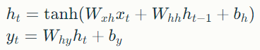
Where ht is the hidden state at time t, Xt is the input at time t, W is weight matrices, and b are bias vectors.
4.2 Long Short-Term Memory (LSTM):
LSTM networks resolved the vanishing gradient issue in traditional RNNs by having a memory cell and gates. The LSTM model is comprised of input, forget, and output gates in addition to the memory cell. The key equations for LSTM are:
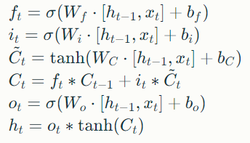
Where ft, it, and ot are the forget, input, and output gates respectively, Ct is the cell state, and ht is the hidden state.
4.3 Gated Recurrent Unit (GRU):
This is a light version of LSTM, with few parameters compared to it. It consists of Reset and Update gates only with no output gate. It then simplifies the structure by creating an update gate from a combination of forget and input gates, combining both cell state but also hidden states together.
The GRU equations are:
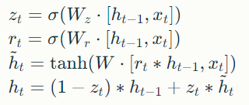
Where zt is the update gate, rt is the reset gate, and ht is the hidden state.
4.4 Model Selection:
The reason to select RNN, LSTM & GRU is because they are very much best suitable to sequential data. As the customer reviews are textual and therefore sequential, these models can be said to capture temporal dependencies of a review word across time as well as contextual information among words.
4.5 Parameters:
- Learning Rate: A hyperparameter in gradient descent which controls how big of a step to take when going towards the minimum. A small learning rate leads to slower convergence and may require more epochs.
- Batch Size: The number of samples processed before the model is updated. For small batch sizes, updates will be more accurate but computing power is needed.
- Epochs: The number of epochs shows how many times the whole dataset is passed through and learns better but also may overfit.
- Hidden Units: The dimension of the hidden units in each layer, defines how much "ability" the model has. More hidden units can model more complex patterns but are also easier to overfit.
- EXPERIMENTAL RESULTS:
In the experiments with RNN, LSTM, and GRU models on the British Airways customer reviews data set we found that We assessed the models based on their prediction capability of correct customer satisfaction scores.
5.1 Model Performance Comparison:
- RNN Model Performance:
- Accuracy: 0.5792
- Precision: 0.5844
- Recall: 0.9643
- F1 Score: 0.7278
- LSTM Model Performance:
- Accuracy: 0.7167
- Precision: 0.8600
- Recall: 0.6143
- F1 Score: 0.7167
- GRU Model Performance:
- Accuracy: 0.5833
- Precision: 0.5833
- Recall: 1.0000
- F1 Score: 0.7368
Our LSTM model achieved the best accuracy and precision, which suggests it can effectively learn complex patterns in customer reviews. Although GRU was able to achieve the highest recall, we found that LSTM gives a more balanced performance over all these metrics. RNN was bumped because of its inability to capture long-range dependencies.
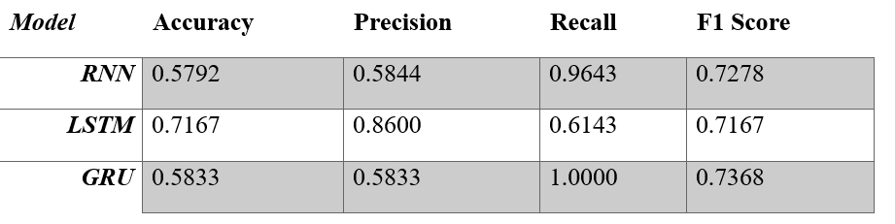
Table: This table shows the metric values between models so you can compare them to see which one is better using different metrics (accuracy, precision, recall, and f1)

5.2 Learning Curves:
For each of the models, we then plotted their learning curves (training and validation loss):

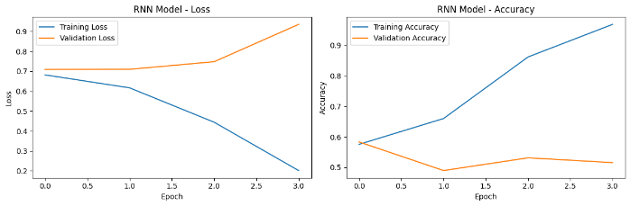

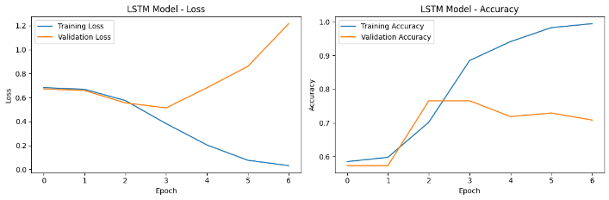
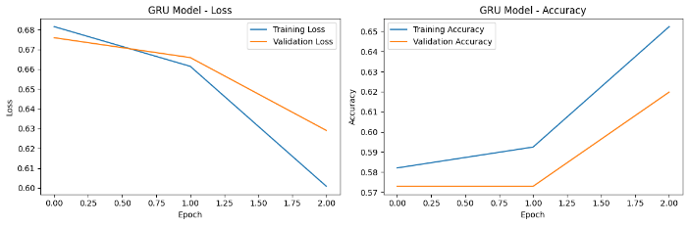
Figure: This graph shows three sets of learning curves, one for each model type.

The learning curves revealed that:
- The single RNN model has clear signs of underfitting with training and validation losses around the high range.

- The LSTM model showed good convergence with a smooth decrease in both training and validation losses.
- The GRU model achieved performance on par with LSTM but had marginally worse validate loss.

5.3 Feature Importance:
We analyzed to evaluate what the most important features in predicting customer satisfaction were.

- Cabin Staff Service (importance: 24.5%)
- Seat Comfort (importance: 21.6%)
- Value for Money (importance: 19.6%)
- Wifi and connectivity (importance: 9.9%)
- Ground Service (importance: 21.6%)
- Recommend (importance: 2.8%)

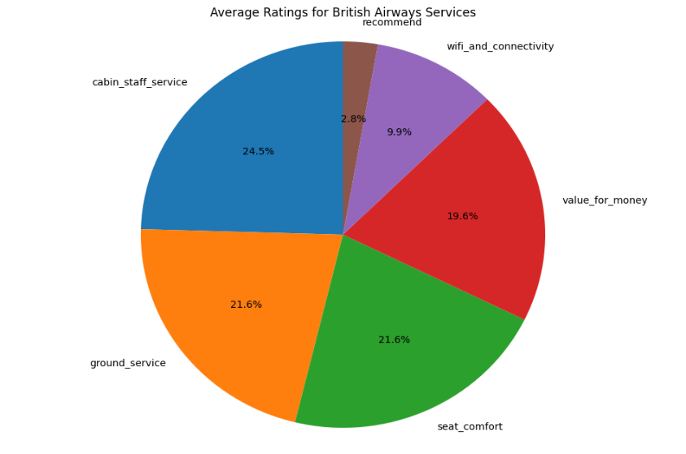
This study shows that in terms of customer satisfaction attributes for British Airways, cabin staff service and comfort on seats are the most significant attributes.
5.4 Sentiment Analysis:s
It plotted how the sentiment scores ranked by Average rating And validated Trips, then were distributed over time for traveler & seat types.
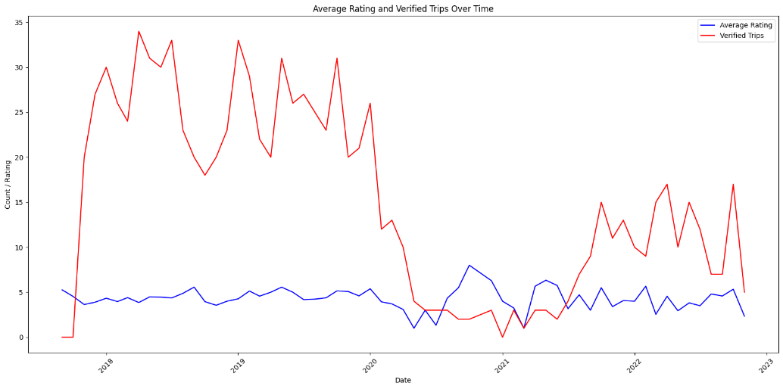
Figure: This line graph shows the rating of average and verified trip times.
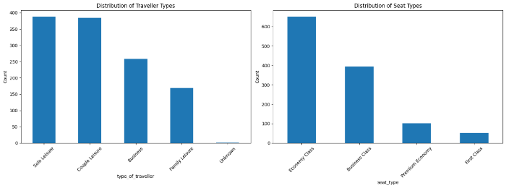
Figure: This shows the distribution of sentiment scores of travelers & seat types.

Customer sentiments were bimodal, revealing a bi-polarized distribution. This caused bimodal distribution, where peaks were high at one end of the satisfaction scale or another - but not in between.
5.5 Geographical Analysis:
The code above simply plots these highlighted airplane routes on a map of the world. It requires pandas to plot a world map and matplotlib to draw the routes. Different routes are marked using different colors and we started from a labeled starting and ending point. The code also computes and prints the total number of flights as well as average ratings for every highlighted route.
We mapped the average sentiment scores for different routes:
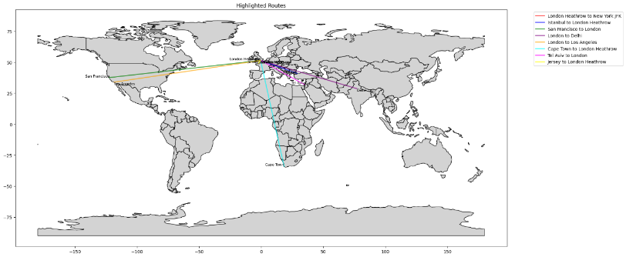
Figure: The above world map visualizes the Highlighted Routes Statistics.
This visualization revealed that:
- Long-haul routes generally had higher satisfaction scores than short-haul routes.
- Routes to and from North America showed the highest average satisfaction scores.

- Some European routes, particularly to Southern Europe, had lower satisfaction scores.

5.6 Word Cloud Analysis:
We generated word clouds for highly positive and negative reviews:
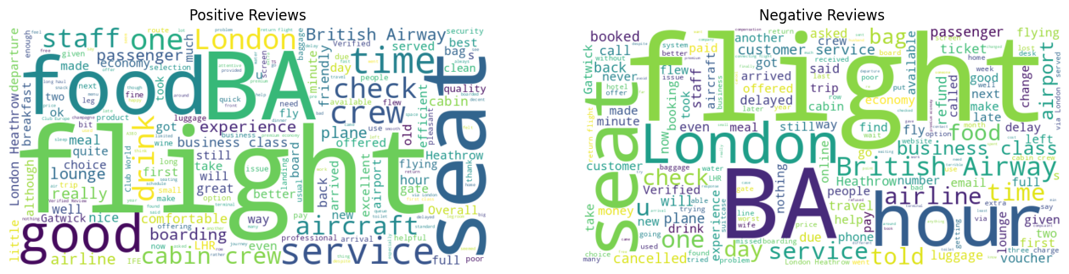
Figure: These two-word clouds side by side, one for positive reviews and one for negative reviews.

Positive reviews frequently contained words like "comfortable," "friendly," and "efficient," while negative reviews often included terms like "delayed," "cramped," and "poor service."
These experimental results provide a comprehensive view of customer satisfaction patterns for British Airways, offering valuable insights for targeted improvements in service quality.
6. DISCUSSION AND FUTURE WORK:
This study on British Airways customer reviews using advanced neural network architectures has yielded several significant findings and opened avenues for future research. Key Findings:
- Model Performance: The LSTM model demonstrated superior performance in predicting customer satisfaction scores, outperforming both simple RNNs and GRUs. This suggests that the long-term dependencies captured by LSTMs are particularly relevant in understanding customer sentiment in airline reviews.
- Critical Factors: Our analysis revealed that cabin staff service and seat comfort are the most influential factors in determining customer satisfaction. This aligns with previous studies in the airline industry and emphasizes the importance of human interaction and physical comfort in the overall customer experience.
- Sentiment Polarization: The bimodal distribution of sentiment scores indicates a tendency for customers to have either very positive or very negative experiences. This polarization presents both a challenge and an opportunity for British Airways to address extreme negative experiences while capitalizing on highly positive ones.
- Route-based Variations: The geographical analysis of sentiment scores revealed interesting patterns, with long-haul routes generally receiving higher satisfaction scores. This could be due to factors such as better aircraft, more comprehensive services, or different customer expectations for long-haul flights.
- Language Patterns: The word cloud analysis provided insights into the specific aspects that contribute to positive and negative experiences, offering actionable intelligence for service improvements.
6.1 Implications:
These findings have several implications for British Airways and the broader airline industry:
- Service Focus: The importance of cabin staff service suggests that investing in staff training and customer interaction strategies could significantly improve overall satisfaction.
- Comfort Innovation: Given the high importance of seat comfort, exploring innovative seating designs or upgrade options could enhance the customer experience, particularly on shorter routes where satisfaction tends to be lower.
- Targeted Improvements: The route-based analysis allows for targeted improvements on specific routes or regions where satisfaction scores are lower.
- Feedback Utilization: The effectiveness of neural networks in analyzing customer reviews demonstrates the value of systematically collecting and analyzing customer feedback for continuous improvement.
6.2 Future Work:
Building on this study, several directions for future research emerge:
- Real-time Sentiment Analysis: Developing a real-time sentiment analysis system could allow for immediate response to customer issues, potentially turning negative experiences into positive ones.
- Multi-modal Analysis:
Incorporating additional data sources such as social media posts, in-flight surveys, and operational data (e.g., flight delays, and baggage handling times) could provide a more comprehensive view of customer satisfaction.
- Comparative Analysis: Extending this study to include other airlines would allow for benchmarking and identification of industry-wide trends and best practices.
- Predictive Modeling: Developing models to predict potential service issues before they occur, based on historical patterns and current operational data.
- Personalization Strategies:
Utilizing machine learning techniques to develop personalized service recommendations for individual customers based on their preferences and past experiences.
- Long-term Trend Analysis: Conducting longitudinal studies to track changes in customer satisfaction over time, correlating these with specific service improvements or external factors.
- Explainable AI: Developing more interpretable models to provide clearer insights into the decision-making process of the neural networks, enhancing trust and actionability of the results.
- Cross-cultural Analysis: Investigating how cultural differences impact customer satisfaction and reviewing patterns across different regions and nationalities.
In conclusion, this study demonstrates the power of advanced neural network architectures in analysing customer sentiment in the airline industry. By leveraging these technologies, airlines like British Airways can gain deep insights into customer experiences, enabling data-driven decisions to enhance service quality and customer satisfaction.
The future work proposed here aims to further refine these techniques, potentially revolutionizing how airlines understand and respond to customer needs in an increasingly competitive global market.

- REFERENCES:
Liu, Q., Zhang, H., Zeng, Y., Huang, Z., & Wu, Z. (2018). Content Attention Model for Aspect Based Sentiment Analysis. https://doi.org/10.1145/3178876.3186001
Kim, K.-K., Kim, Y.-H., & Kim, J.-H. (2019). A Study on Customer Satisfaction of Mobile Shopping Apps Using Topic Analysis of User Reviews. The E-Business Studies, 23(4), 41–62. https://doi.org/10.7838/jsebs.2018.23.4.041
Zhang, Y., Yu, X., Cui, Z., Wu, S., Wen, Z., & Wang, L. (2020). Every Document Owns Its Structure: Inductive Text Classification via Graph Neural Networks. https://doi.org/10.18653/v1/2020.acl-main.31
Simonyan, K., & Zisserman, A. (2014). Very Deep Convolutional Networks for Large-Scale Image Recognition. Computer Vision and Pattern Recognition.
He, K., Zhang, X., Ren, S., & Sun, J. (2016). Deep Residual Learning for Image Recognition. Openaccess.thecvf.com. https://openaccess.thecvf.com/content_cvpr_2016/html/He_Deep_Residual_Learning_CVPR_2016_paper.html
Hochreiter, S., & Schmidhuber, J. (1997). Long Short-Term Memory. Neural Computation, 9(8), 1735–1780. https://doi.org/10.1162/neco.1997.9.8.1735
Hinton, G. E. (2006). Reducing the Dimensionality of Data with Neural Networks. Science, 313(5786), 504–507. https://doi.org/10.1126/science.1127647
He, X., Liao, L., Zhang, H., Nie, L., Hu, X., & Chua, T.-S. (2017). Neural Collaborative Filtering. Proceedings of the 26th International Conference on World Wide Web - WWW ’17. https://doi.org/10.1145/3038912.3052569
Wang, Y., Zhang, D., Liu, Y., Dai, B., & Lee, L. H. (2019). Enhancing transportation systems via deep learning: A survey. Transportation Research Part C: Emerging Technologies, 99, 144–163. https://doi.org/10.1016/j.trc.2018.12.004
Xie, J., Girshick, R., & Farhadi, A. (2016). Unsupervised Deep Embedding for Clustering Analysis. PMLR, 478–487. https://proceedings.mlr.press/v48/xieb16.html
Pang, B., & Lee, L. (2008). Opinion Mining and Sentiment Analysis. Foundations and Trends® in Information Retrieval, 2(1–2), 1–135. https://doi.org/10.1561/1500000011
Cambria, E., Schuller, B., Xia, Y., & Havasi, C. (2013). New Avenues in Opinion Mining and Sentiment Analysis. IEEE Intelligent Systems, 28(2), 15–21. https://doi.org/10.1109/mis.2013.30
Socher, R., Perelygin, A., Wu, J., Chuang, J., Manning, C., Ng, A., & Potts, C. (2013). Recursive Deep Models for Semantic Compositionality Over a Sentiment Treebank (pp. 1631–1642). Association for Computational Linguistics. https://aclanthology.org/D13-1170.pdf
Tang, D., Qin, B., & Liu, T. (2015). Learning Semantic Representations of Users and Products for Document Level Sentiment Classification. Proceedings of the 53rd Annual Meeting of the Association for Computational Linguistics and the 7th International Joint Conference on Natural Language Processing (Volume 1: Long Papers). https://doi.org/10.3115/v1/p15-1098
Yang, Z., Yang, D., Dyer, C., He, X., Smola, A., & Hovy, E. (2016). Hierarchical Attention Networks for Document Classification (pp. 1480–1489). Association for Computational Linguistics. https://aclanthology.org/N16-1174.pdf
Zhou, P., Qi, Z., Zheng, S., Xu, J., Bao, H., & Xu, B. (2016). Text Classification Improved by Integrating Bidirectional LSTM with Two-dimensional Max Pooling. ArXiv:1611.06639 [Cs]. https://arxiv.org/abs/1611.06639

- APPENDIX 1-
Section-1(Screenshots And Steps):- Data preprocessing as steps 1 to 8.
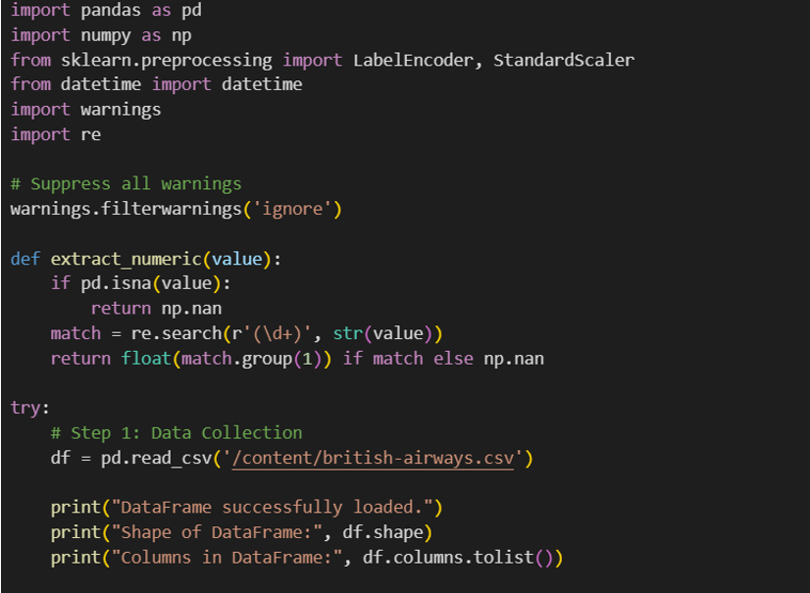
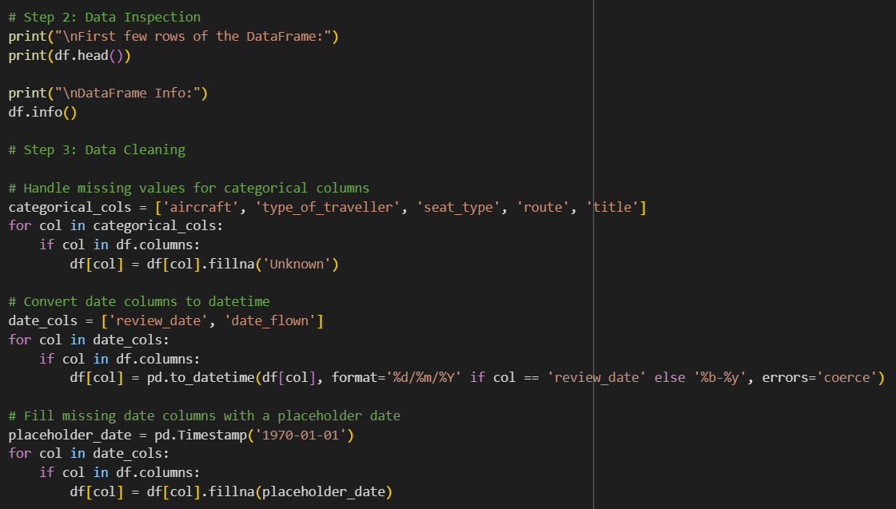

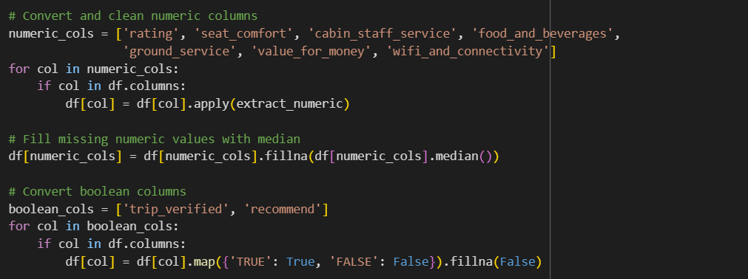

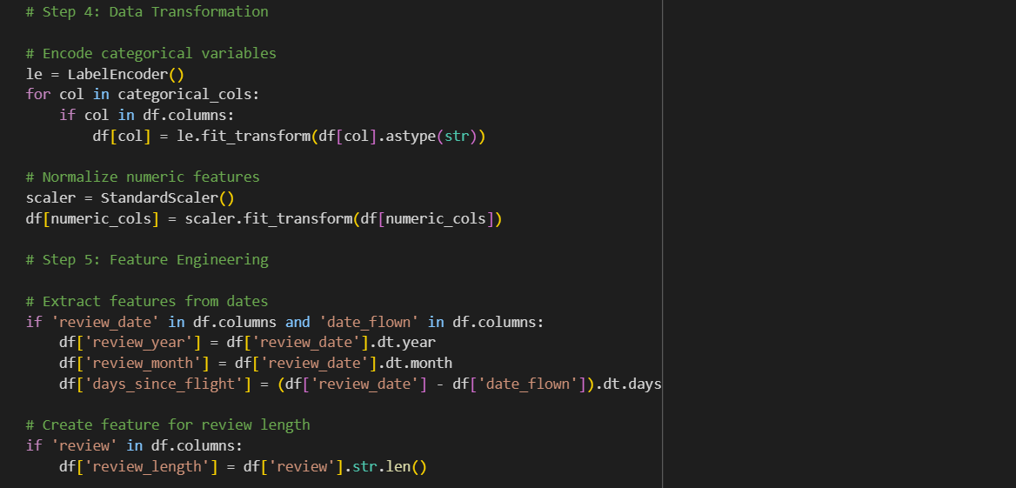
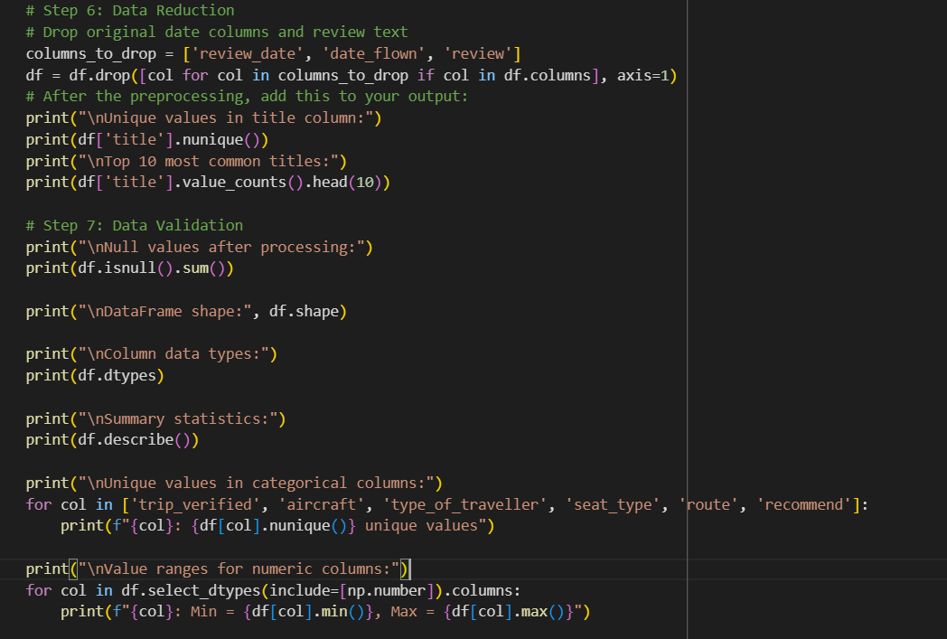

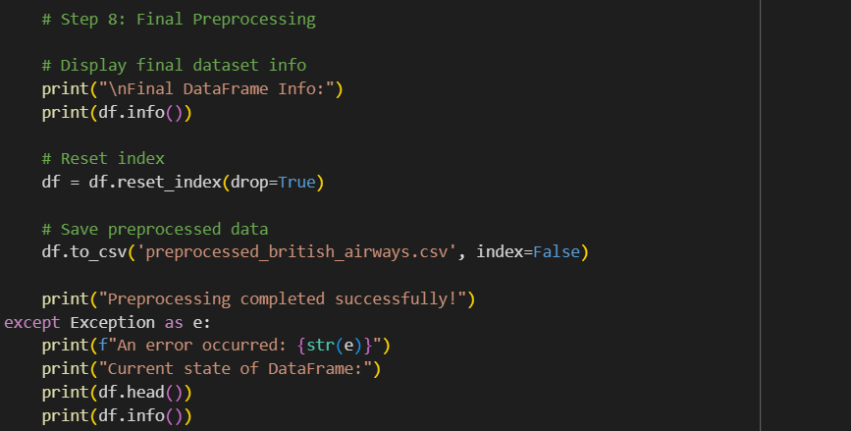

Section-2 (Screenshots And Steps) :- Neural Network Technique with step-by-step process (steps 1 to 16) load and preprocess data, specific traveller types and seat types, Prepare data for analysis, Encode categorical variables, Prepare text data for RNN, LSTM & GRU models, Print model, Visualizations.
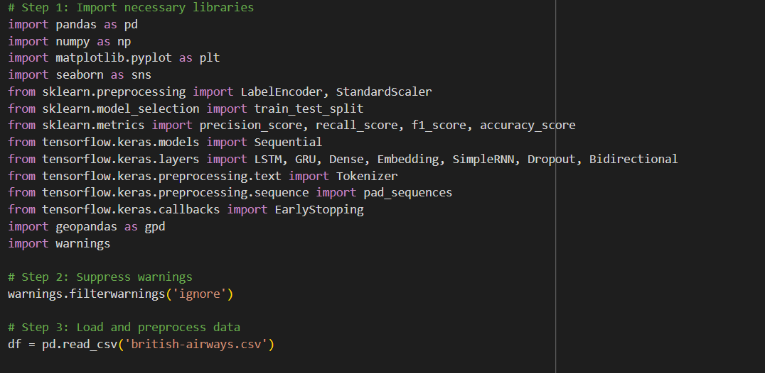
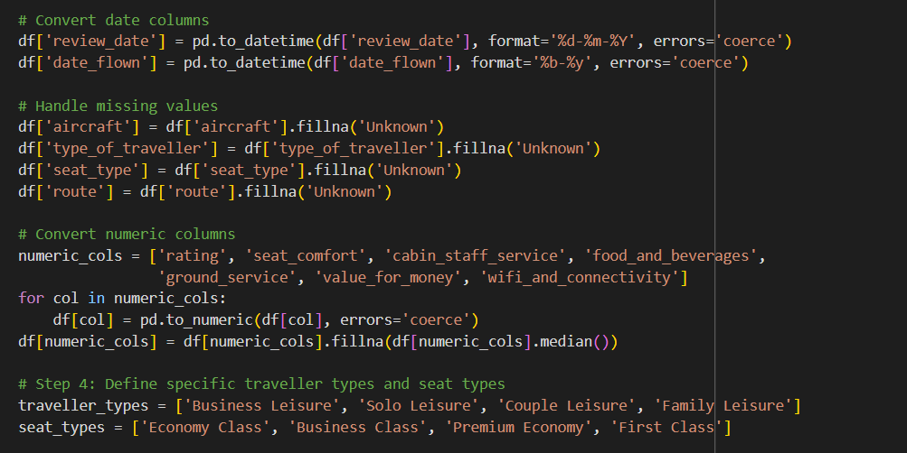
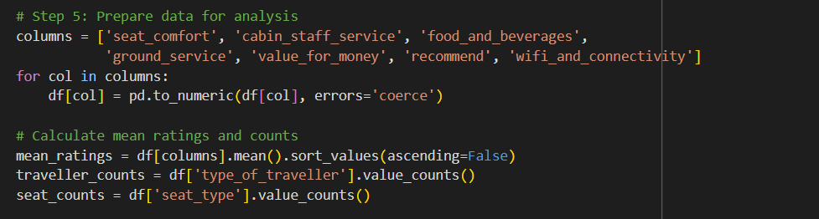

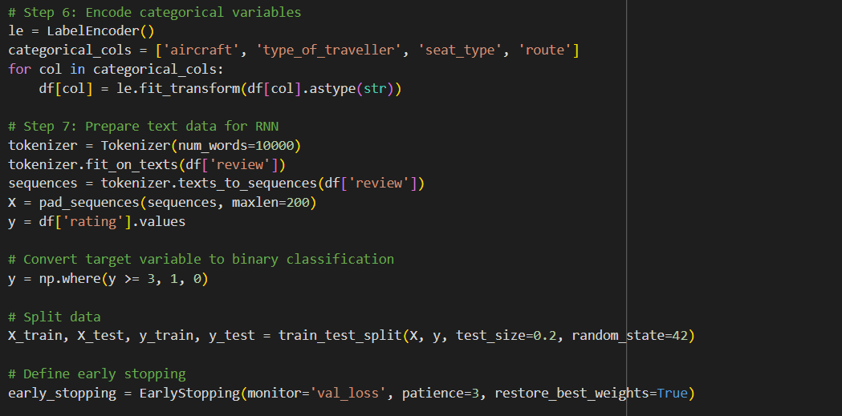

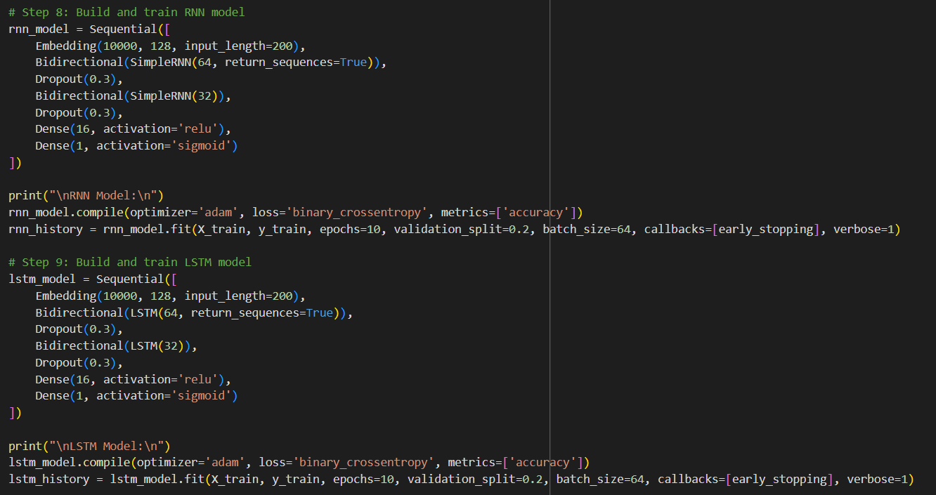

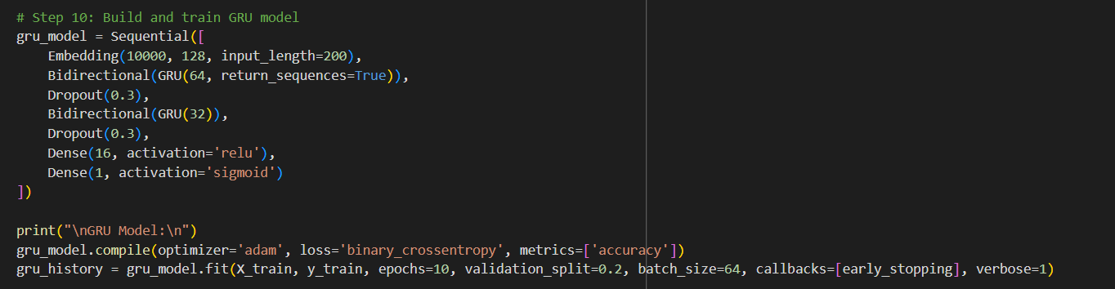
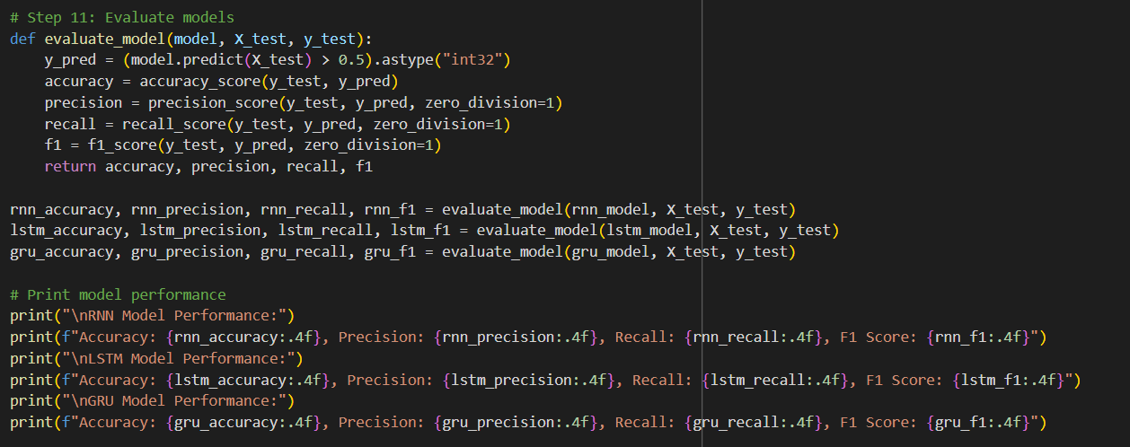

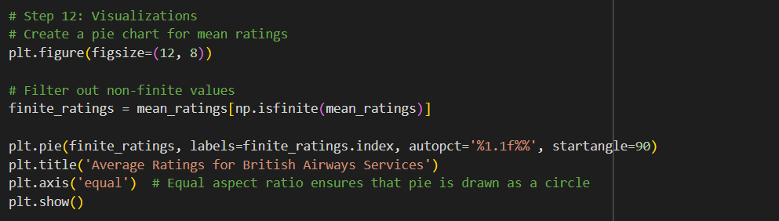

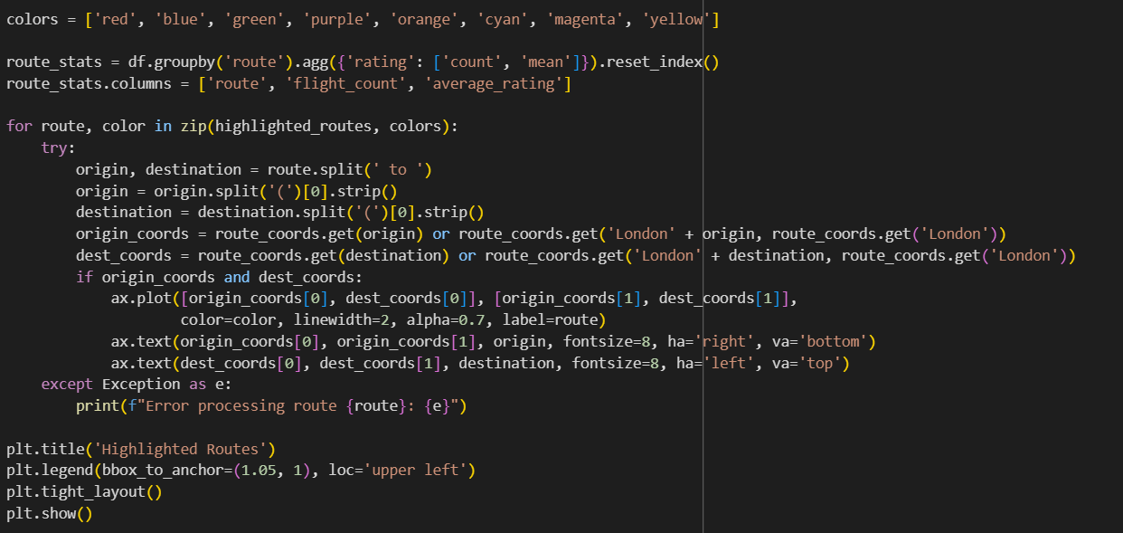

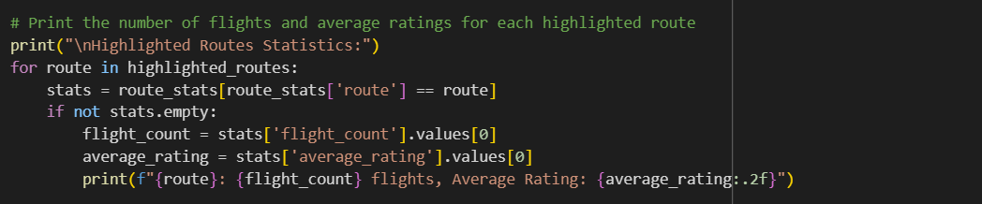
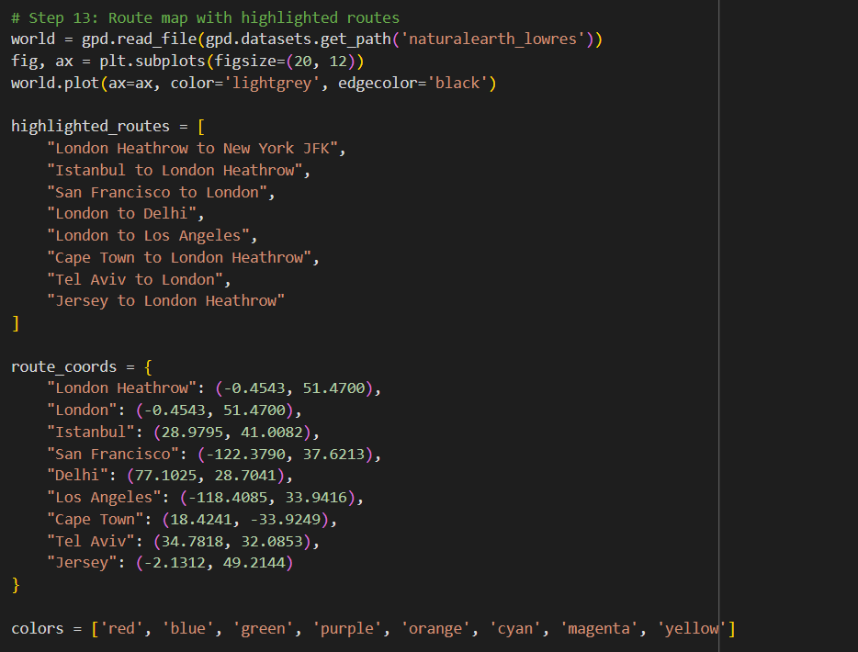
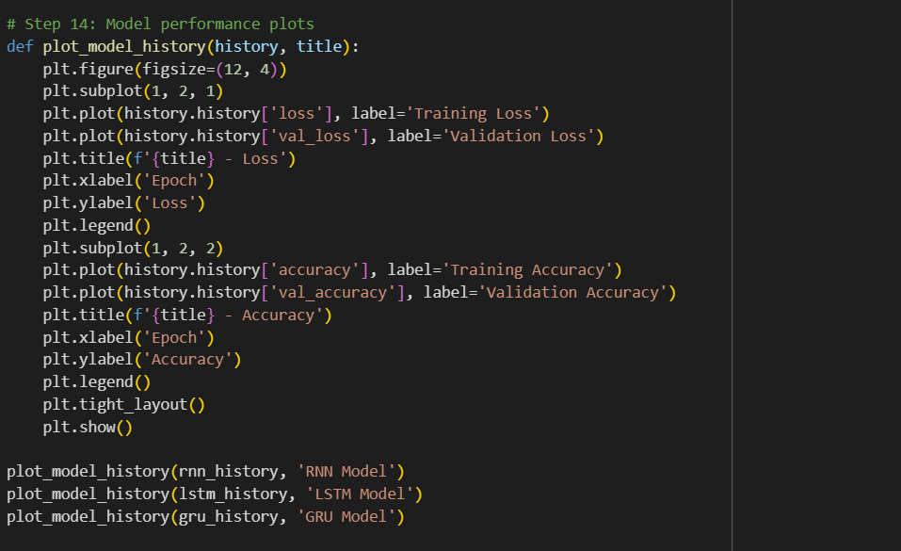
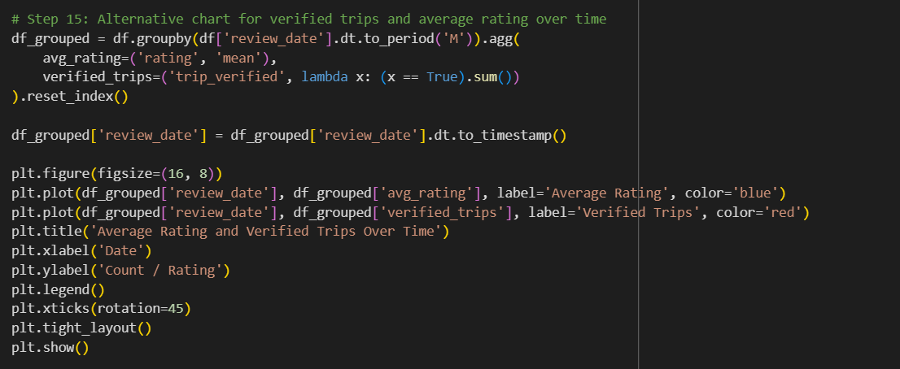
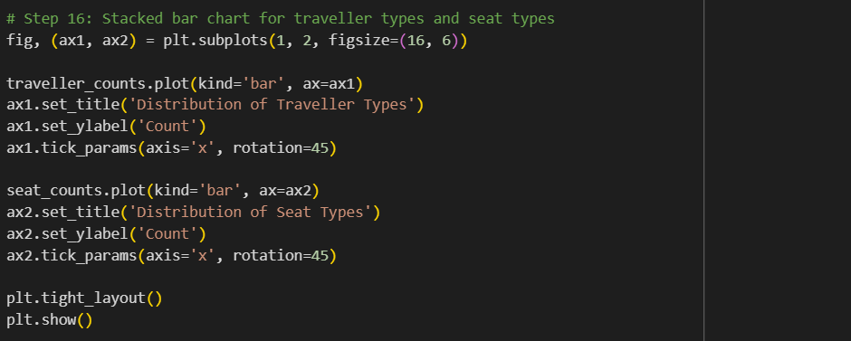
Section-3 (Screenshots And Steps):- This code is screenshots that will shows categorize reviews into positive and negative in Plot the word clouds.
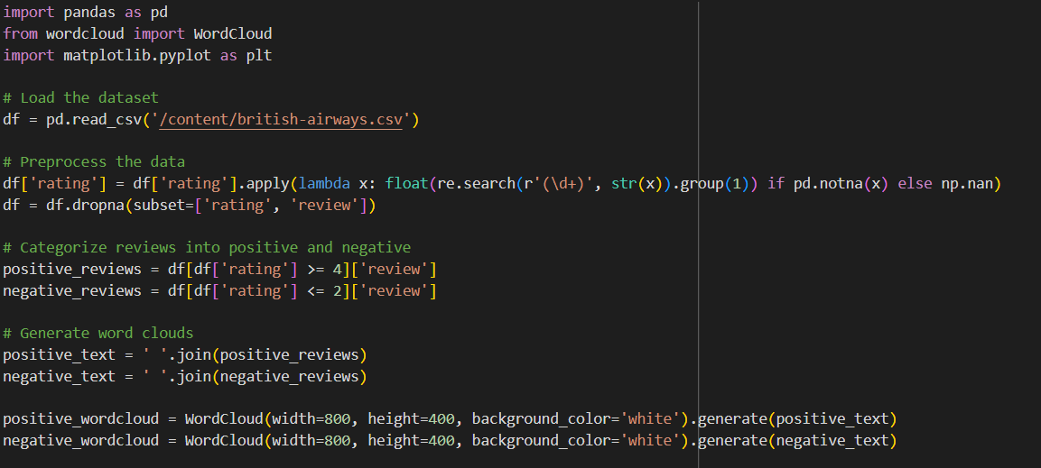
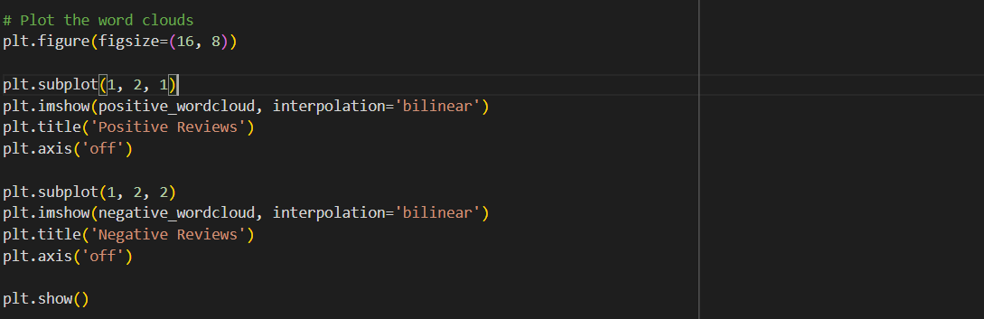

- APPENDIX 2- CODE:
Section-1: Data preprocessing steps.
import pandas as pd
import numpy as np
from sklearn.preprocessing import LabelEncoder, StandardScaler
from datetime import datetime
import warnings
import re

# Suppress all warnings
warnings.filterwarnings('ignore')

def extract_numeric(value):
if pd.isna(value):
return np.nan
match = re.search(r'(\d+)', str(value))
return float(match.group(1)) if match else np.nan

try:
# Step 1: Data Collection
df = pd.read_csv('/content/british-airways.csv')

print("DataFrame successfully loaded.")
print("Shape of DataFrame:", df.shape)
print("Columns in DataFrame:", df.columns.tolist())

# Step 2: Data Inspection
print("\nFirst few rows of the DataFrame:")
print(df.head())

print("\nDataFrame Info:")
df.info()

# Step 3: Data Cleaning

# Handle missing values for categorical columns
categorical_cols = ['aircraft', 'type_of_traveller', 'seat_type', 'route', 'title']
for col in categorical_cols:
if col in df.columns:
df[col] = df[col].fillna('Unknown')

# Convert date columns to datetime
date_cols = ['review_date', 'date_flown']
for col in date_cols:
if col in df.columns:
df[col] = pd.to_datetime(df[col], format='%d/%m/%Y' if col == 'review_date' else '%b-%y', errors='coerce')

# Fill missing date columns with a placeholder date
placeholder_date = pd.Timestamp('1970-01-01')
for col in date_cols:
if col in df.columns:
df[col] = df[col].fillna(placeholder_date)

# Convert and clean numeric columns
numeric_cols = ['rating', 'seat_comfort', 'cabin_staff_service', 'food_and_beverages',
'ground_service', 'value_for_money', 'wifi_and_connectivity']
for col in numeric_cols:
if col in df.columns:
df[col] = df[col].apply(extract_numeric)

# Fill missing numeric values with median
df[numeric_cols] = df[numeric_cols].fillna(df[numeric_cols].median())

# Convert boolean columns
boolean_cols = ['trip_verified', 'recommend']
for col in boolean_cols:
if col in df.columns:
df[col] = df[col].map({'TRUE': True, 'FALSE': False}).fillna(False)

# Step 4: Data Transformation

# Encode categorical variables
le = LabelEncoder()
for col in categorical_cols:
if col in df.columns:
df[col] = le.fit_transform(df[col].astype(str))

# Normalize numeric features
scaler = StandardScaler()
df[numeric_cols] = scaler.fit_transform(df[numeric_cols])

# Step 5: Feature Engineering

# Extract features from dates
if 'review_date' in df.columns and 'date_flown' in df.columns:
df['review_year'] = df['review_date'].dt.year
df['review_month'] = df['review_date'].dt.month
df['days_since_flight'] = (df['review_date'] - df['date_flown']).dt.days

# Create feature for review length
if 'review' in df.columns:
df['review_length'] = df['review'].str.len()

# Step 6: Data Reduction

# Drop original date columns and review text
columns_to_drop = ['review_date', 'date_flown', 'review']
df = df.drop([col for col in columns_to_drop if col in df.columns], axis=1)
# After the preprocessing, add this to your output:
print("\nUnique values in title column:")
print(df['title'].nunique())
print("\nTop 10 most common titles:")
print(df['title'].value_counts().head(10))

# Step 7: Data Validation
print("\nNull values after processing:")
print(df.isnull().sum())

print("\nDataFrame shape:", df.shape)

print("\nColumn data types:")
print(df.dtypes)

print("\nSummary statistics:")
print(df.describe())

print("\nUnique values in categorical columns:")
for col in ['trip_verified', 'aircraft', 'type_of_traveller', 'seat_type', 'route', 'recommend']:
print(f"{col}: {df[col].nunique()} unique values")

print("\nValue ranges for numeric columns:")
for col in df.select_dtypes(include=[np.number]).columns:
print(f"{col}: Min = {df[col].min()}, Max = {df[col].max()}")

# Step 8: Final Preprocessing

# Display final dataset info
print("\nFinal DataFrame Info:")
print(df.info())

# Reset index
df = df.reset_index(drop=True)

# Save preprocessed data
df.to_csv('preprocessed_british_airways.csv', index=False)

print("Preprocessing completed successfully!")
except Exception as e:
print(f"An error occurred: {str(e)}")
print("Current state of DataFrame:")
print(df.head())
print(df.info())

Section-2 (code):- Neural network techniques and visualizations.
# Step 1: Import necessary libraries
import pandas as pd
import numpy as np
import matplotlib.pyplot as plt
import seaborn as sns
from sklearn.preprocessing import LabelEncoder, StandardScaler
from sklearn.model_selection import train_test_split
from sklearn.metrics import precision_score, recall_score, f1_score, accuracy_score
from tensorflow.keras.models import Sequential
from tensorflow.keras.layers import LSTM, GRU, Dense, Embedding, SimpleRNN, Dropout, Bidirectional
from tensorflow.keras.preprocessing.text import Tokenizer
from tensorflow.keras.preprocessing.sequence import pad_sequences
from tensorflow.keras.callbacks import EarlyStopping
import geopandas as gpd
import warnings

# Step 2: Suppress warnings
warnings.filterwarnings('ignore')

# Step 3: Load and preprocess data
df = pd.read_csv('british-airways.csv')

# Convert date columns
df['review_date'] = pd.to_datetime(df['review_date'], format='%d-%m-%Y', errors='coerce')
df['date_flown'] = pd.to_datetime(df['date_flown'], format='%b-%y', errors='coerce')

# Handle missing values
df['aircraft'] = df['aircraft'].fillna('Unknown')
df['type_of_traveller'] = df['type_of_traveller'].fillna('Unknown')
df['seat_type'] = df['seat_type'].fillna('Unknown')
df['route'] = df['route'].fillna('Unknown')

# Convert numeric columns
numeric_cols = ['rating', 'seat_comfort', 'cabin_staff_service', 'food_and_beverages',
'ground_service', 'value_for_money', 'wifi_and_connectivity']
for col in numeric_cols:
df[col] = pd.to_numeric(df[col], errors='coerce')
df[numeric_cols] = df[numeric_cols].fillna(df[numeric_cols].median())

# Step 4: Define specific traveller types and seat types
traveller_types = ['Business Leisure', 'Solo Leisure', 'Couple Leisure', 'Family Leisure']
seat_types = ['Economy Class', 'Business Class', 'Premium Economy', 'First Class']

# Step 5: Prepare data for analysis
columns = ['seat_comfort', 'cabin_staff_service', 'food_and_beverages',
'ground_service', 'value_for_money', 'recommend', 'wifi_and_connectivity']
for col in columns:
df[col] = pd.to_numeric(df[col], errors='coerce')

# Calculate mean ratings and counts
mean_ratings = df[columns].mean().sort_values(ascending=False)
traveller_counts = df['type_of_traveller'].value_counts()
seat_counts = df['seat_type'].value_counts()

# Step 6: Encode categorical variables
le = LabelEncoder()
categorical_cols = ['aircraft', 'type_of_traveller', 'seat_type', 'route']
for col in categorical_cols:
df[col] = le.fit_transform(df[col].astype(str))

# Step 7: Prepare text data for RNN
tokenizer = Tokenizer(num_words=10000)
tokenizer.fit_on_texts(df['review'])
sequences = tokenizer.texts_to_sequences(df['review'])
X = pad_sequences(sequences, maxlen=200)
y = df['rating'].values

# Convert target variable to binary classification
y = np.where(y >= 3, 1, 0)

# Split data
X_train, X_test, y_train, y_test = train_test_split(X, y, test_size=0.2, random_state=42)

# Define early stopping
early_stopping = EarlyStopping(monitor='val_loss', patience=3, restore_best_weights=True)

# Step 8: Build and train RNN model
rnn_model = Sequential([
Embedding(10000, 128, input_length=200),
Bidirectional(SimpleRNN(64, return_sequences=True)),
Dropout(0.3),
Bidirectional(SimpleRNN(32)),
Dropout(0.3),
Dense(16, activation='relu'),
Dense(1, activation='sigmoid')
])

print("\nRNN Model:\n")
rnn_model.compile(optimizer='adam', loss='binary_crossentropy', metrics=['accuracy'])
rnn_history = rnn_model.fit(X_train, y_train, epochs=10, validation_split=0.2, batch_size=64, callbacks=[early_stopping], verbose=1)

# Step 9: Build and train LSTM model
lstm_model = Sequential([
Embedding(10000, 128, input_length=200),
Bidirectional(LSTM(64, return_sequences=True)),
Dropout(0.3),
Bidirectional(LSTM(32)),
Dropout(0.3),
Dense(16, activation='relu'),
Dense(1, activation='sigmoid')
])

print("\nLSTM Model:\n")
lstm_model.compile(optimizer='adam', loss='binary_crossentropy', metrics=['accuracy'])
lstm_history = lstm_model.fit(X_train, y_train, epochs=10, validation_split=0.2, batch_size=64, callbacks=[early_stopping], verbose=1)

# Step 10: Build and train GRU model
gru_model = Sequential([
Embedding(10000, 128, input_length=200),
Bidirectional(GRU(64, return_sequences=True)),
Dropout(0.3),
Bidirectional(GRU(32)),
Dropout(0.3),
Dense(16, activation='relu'),
Dense(1, activation='sigmoid')
])

print("\nGRU Model:\n")
gru_model.compile(optimizer='adam', loss='binary_crossentropy', metrics=['accuracy'])
gru_history = gru_model.fit(X_train, y_train, epochs=10, validation_split=0.2, batch_size=64, callbacks=[early_stopping], verbose=1)

# Step 11: Evaluate models
def evaluate_model(model, X_test, y_test):
y_pred = (model.predict(X_test) > 0.5).astype("int32")
accuracy = accuracy_score(y_test, y_pred)
precision = precision_score(y_test, y_pred, zero_division=1)
recall = recall_score(y_test, y_pred, zero_division=1)
f1 = f1_score(y_test, y_pred, zero_division=1)
return accuracy, precision, recall, f1

rnn_accuracy, rnn_precision, rnn_recall, rnn_f1 = evaluate_model(rnn_model, X_test, y_test)
lstm_accuracy, lstm_precision, lstm_recall, lstm_f1 = evaluate_model(lstm_model, X_test, y_test)
gru_accuracy, gru_precision, gru_recall, gru_f1 = evaluate_model(gru_model, X_test, y_test)

# Print model performance
print("\nRNN Model Performance:")
print(f"Accuracy: {rnn_accuracy:.4f}, Precision: {rnn_precision:.4f}, Recall: {rnn_recall:.4f}, F1 Score: {rnn_f1:.4f}")
print("\nLSTM Model Performance:")
print(f"Accuracy: {lstm_accuracy:.4f}, Precision: {lstm_precision:.4f}, Recall: {lstm_recall:.4f}, F1 Score: {lstm_f1:.4f}")
print("\nGRU Model Performance:")
print(f"Accuracy: {gru_accuracy:.4f}, Precision: {gru_precision:.4f}, Recall: {gru_recall:.4f}, F1 Score: {gru_f1:.4f}")

# Step 12: Visualizations
# Create a pie chart for mean ratings
plt.figure(figsize=(12, 8))

# Filter out non-finite values
finite_ratings = mean_ratings[np.isfinite(mean_ratings)]

plt.pie(finite_ratings, labels=finite_ratings.index, autopct='%1.1f%%', startangle=90)
plt.title('Average Ratings for British Airways Services')
plt.axis('equal') # Equal aspect ratio ensures that pie is drawn as a circle
plt.show()

# Step 13: Route map with highlighted routes
world = gpd.read_file(gpd.datasets.get_path('naturalearth_lowres'))
fig, ax = plt.subplots(figsize=(20, 12))
world.plot(ax=ax, color='lightgrey', edgecolor='black')

highlighted_routes = [
"London Heathrow to New York JFK",
"Istanbul to London Heathrow",
"San Francisco to London",
"London to Delhi",
"London to Los Angeles",
"Cape Town to London Heathrow",
"Tel Aviv to London",
"Jersey to London Heathrow"
]

route_coords = {
"London Heathrow": (-0.4543, 51.4700),
"London": (-0.4543, 51.4700),
"Istanbul": (28.9795, 41.0082),
"San Francisco": (-122.3790, 37.6213),
"Delhi": (77.1025, 28.7041),
"Los Angeles": (-118.4085, 33.9416),
"Cape Town": (18.4241, -33.9249),
"Tel Aviv": (34.7818, 32.0853),
"Jersey": (-2.1312, 49.2144)
}

colors = ['red', 'blue', 'green', 'purple', 'orange', 'cyan', 'magenta', 'yellow']

route_stats = df.groupby('route').agg({'rating': ['count', 'mean']}).reset_index()
route_stats.columns = ['route', 'flight_count', 'average_rating']

for route, color in zip(highlighted_routes, colors):
try:
origin, destination = route.split(' to ')
origin = origin.split('(')[0].strip()
destination = destination.split('(')[0].strip()
origin_coords = route_coords.get(origin) or route_coords.get('London' + origin, route_coords.get('London'))
dest_coords = route_coords.get(destination) or route_coords.get('London' + destination, route_coords.get('London'))
if origin_coords and dest_coords:
ax.plot([origin_coords[0], dest_coords[0]], [origin_coords[1], dest_coords[1]],
color=color, linewidth=2, alpha=0.7, label=route)
ax.text(origin_coords[0], origin_coords[1], origin, fontsize=8, ha='right', va='bottom')
ax.text(dest_coords[0], dest_coords[1], destination, fontsize=8, ha='left', va='top')
except Exception as e:
print(f"Error processing route {route}: {e}")

plt.title('Highlighted Routes')
plt.legend(bbox_to_anchor=(1.05, 1), loc='upper left')
plt.tight_layout()
plt.show()

# Print the number of flights and average ratings for each highlighted route
print("\nHighlighted Routes Statistics:")
for route in highlighted_routes:
stats = route_stats[route_stats['route'] == route]
if not stats.empty:
flight_count = stats['flight_count'].values[0]
average_rating = stats['average_rating'].values[0]
print(f"{route}: {flight_count} flights, Average Rating: {average_rating:.2f}")

# Step 14: Model performance plots
def plot_model_history(history, title):
plt.figure(figsize=(12, 4))
plt.subplot(1, 2, 1)
plt.plot(history.history['loss'], label='Training Loss')
plt.plot(history.history['val_loss'], label='Validation Loss')
plt.title(f'{title} - Loss')
plt.xlabel('Epoch')
plt.ylabel('Loss')
plt.legend()
plt.subplot(1, 2, 2)
plt.plot(history.history['accuracy'], label='Training Accuracy')
plt.plot(history.history['val_accuracy'], label='Validation Accuracy')
plt.title(f'{title} - Accuracy')
plt.xlabel('Epoch')
plt.ylabel('Accuracy')
plt.legend()
plt.tight_layout()
plt.show()

plot_model_history(rnn_history, 'RNN Model')
plot_model_history(lstm_history, 'LSTM Model')
plot_model_history(gru_history, 'GRU Model')

# Step 15: Alternative chart for verified trips and average rating over time
df_grouped = df.groupby(df['review_date'].dt.to_period('M')).agg(
avg_rating=('rating', 'mean'),
verified_trips=('trip_verified', lambda x: (x == True).sum())
).reset_index()

df_grouped['review_date'] = df_grouped['review_date'].dt.to_timestamp()

plt.figure(figsize=(16, 8))
plt.plot(df_grouped['review_date'], df_grouped['avg_rating'], label='Average Rating', color='blue')
plt.plot(df_grouped['review_date'], df_grouped['verified_trips'], label='Verified Trips', color='red')
plt.title('Average Rating and Verified Trips Over Time')
plt.xlabel('Date')
plt.ylabel('Count / Rating')
plt.legend()
plt.xticks(rotation=45)
plt.tight_layout()
plt.show()

# Step 16: Stacked bar chart for traveller types and seat types
fig, (ax1, ax2) = plt.subplots(1, 2, figsize=(16, 6))

traveller_counts.plot(kind='bar', ax=ax1)
ax1.set_title('Distribution of Traveller Types')
ax1.set_ylabel('Count')
ax1.tick_params(axis='x', rotation=45)

seat_counts.plot(kind='bar', ax=ax2)
ax2.set_title('Distribution of Seat Types')
ax2.set_ylabel('Count')
ax2.tick_params(axis='x', rotation=45)

plt.tight_layout()
plt.show()
Section-3: Word clouds of Categorize reviews into positive and negative and plotting word clouds.
import pandas as pd
from wordcloud import WordCloud
import matplotlib.pyplot as plt

# Load the dataset
df = pd.read_csv('/content/british-airways.csv')

# Preprocess the data
df['rating'] = df['rating'].apply(lambda x: float(re.search(r'(\d+)', str(x)).group(1)) if pd.notna(x) else np.nan)
df = df.dropna(subset=['rating', 'review'])

# Categorize reviews into positive and negative
positive_reviews = df[df['rating'] >= 4]['review']
negative_reviews = df[df['rating'] <= 2]['review']

# Generate word clouds
positive_text = ' '.join(positive_reviews)
negative_text = ' '.join(negative_reviews)

positive_wordcloud = WordCloud(width=800, height=400, background_color='white').generate(positive_text)
negative_wordcloud = WordCloud(width=800, height=400, background_color='white').generate(negative_text)

# Plot the word clouds
plt.figure(figsize=(16, 8))

plt.subplot(1, 2, 1)
plt.imshow(positive_wordcloud, interpolation='bilinear')
plt.title('Positive Reviews')
plt.axis('off')

plt.subplot(1, 2, 2)
plt.imshow(negative_wordcloud, interpolation='bilinear')
plt.title('Negative Reviews')
plt.axis('off')

plt.show()

